Analysis & Design Models
SRS supplements — use cases, activity, context/DFD, architecture, class & sequence models. All diagrams are Mermaid (GitHub renders natively). IDs cross-reference the user stories (US-xx) in the Requirements Document.

1. Use case diagram
Split into two views for readability (a single diagram with 15 use cases is unreadable on a page). Role inheritance: Manager can do everything a Pharmacist/Inventory Officer can; Admin can do everything (permission matrix in ADR-005).
(a) POS & sales operations
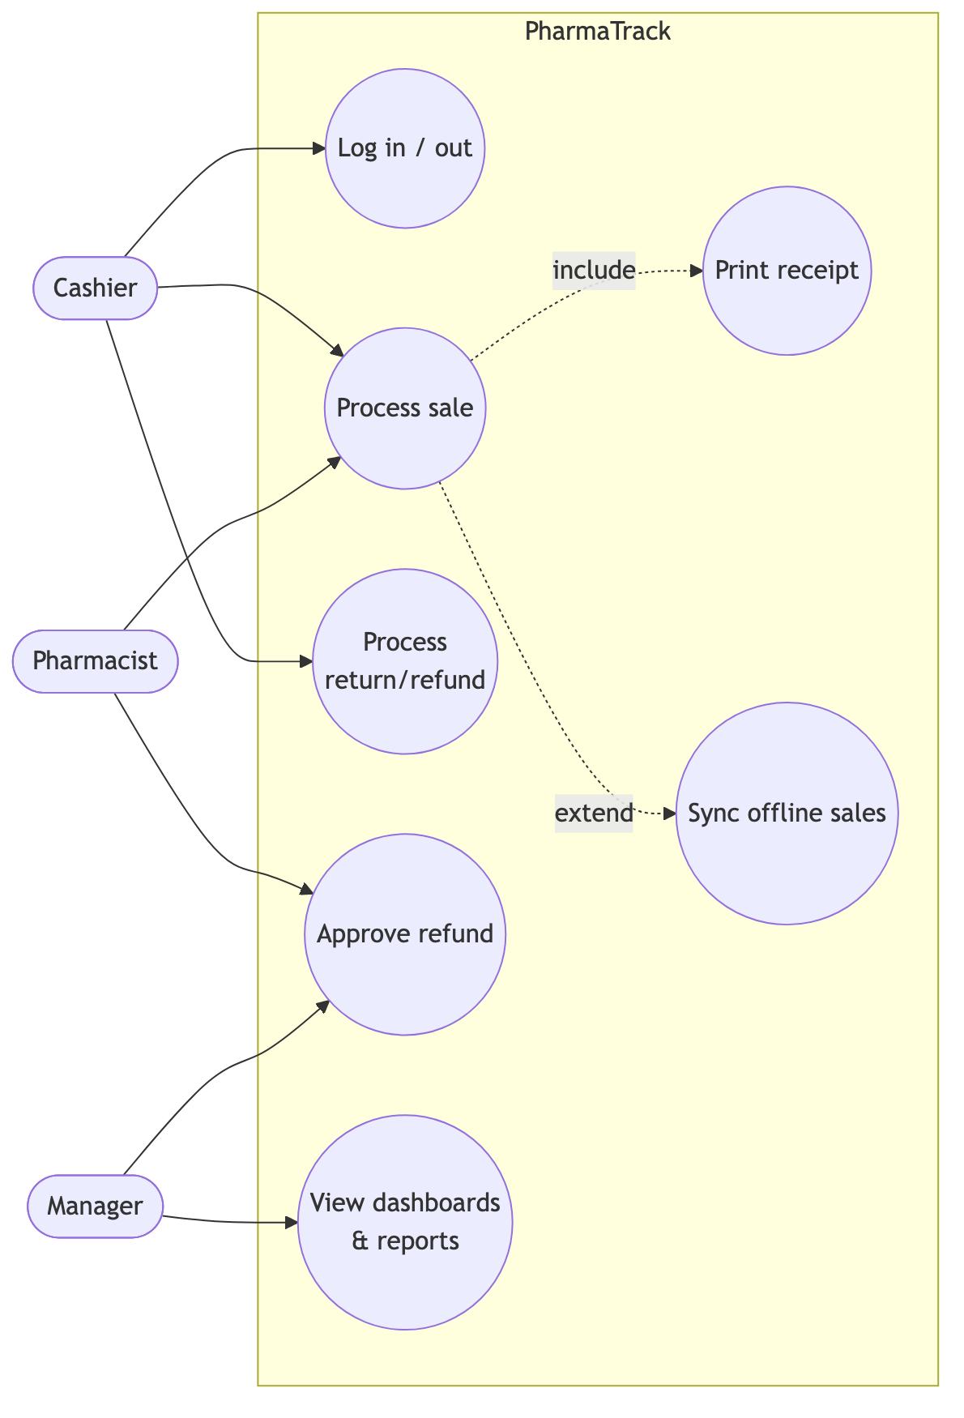
Figure 1
(b) Inventory, purchasing & administration
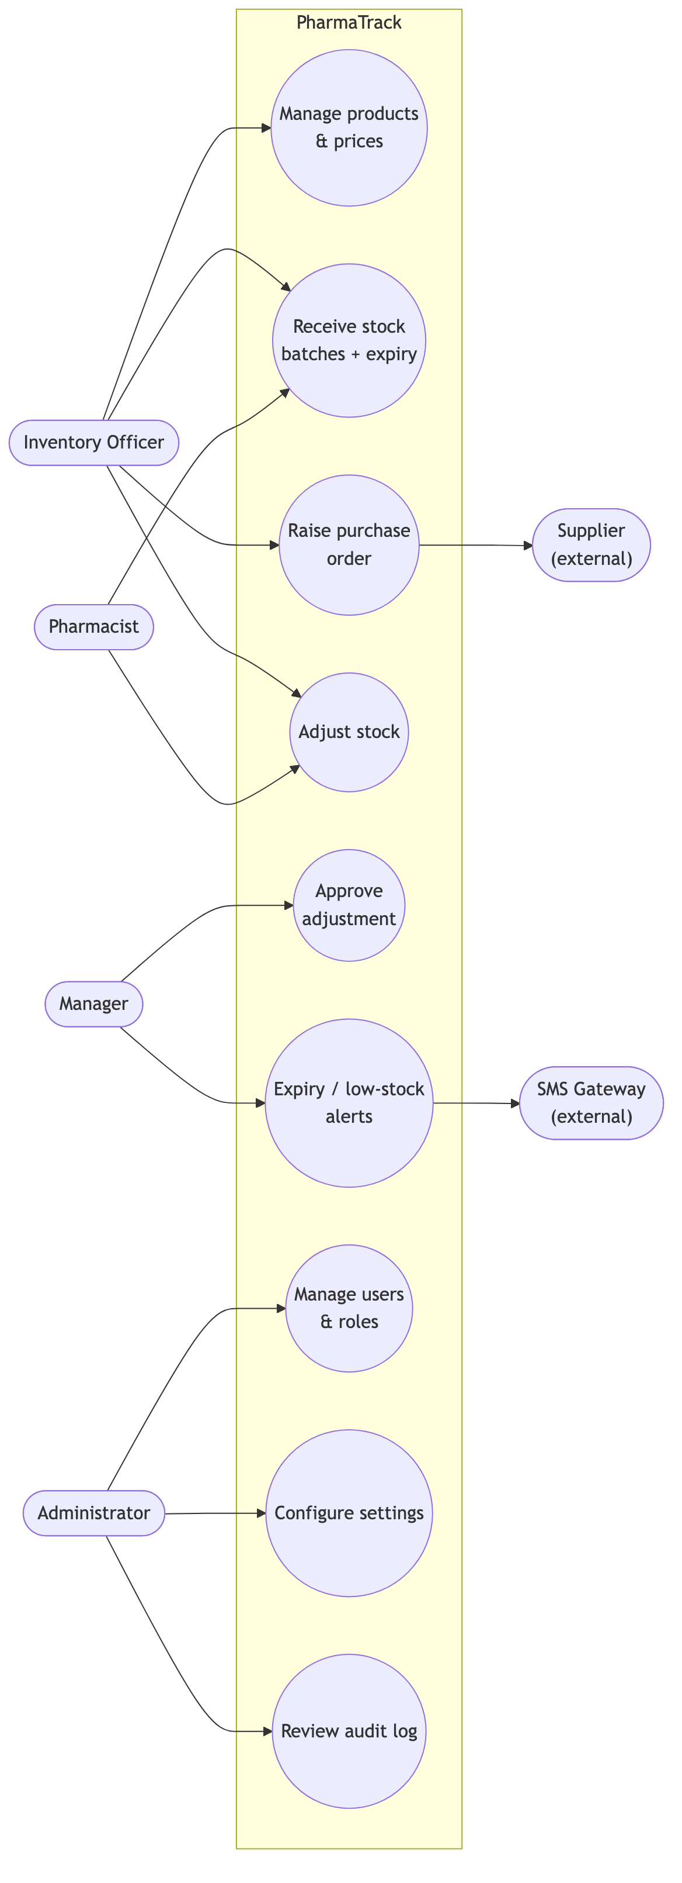
Figure 2

2. Use case descriptions (5 primary)

UC-2 Process sale (US-04/05/06/07/08)
Field | Description
Actors | Cashier (primary), Customer (off-stage)
Preconditions | Cashier authenticated; catalogue cached locally
Main flow | 1. Cashier scans item (or searches by name/generic). 2. System adds line, showing unit options (carton/pack/strip/tablet) and FEFO batch availability. 3. Repeat for all items. 4. Cashier presses F4; enters tendered amount and method. 5. System validates stock atomically, records sale + movements, assigns receipt number. 6. Receipt prints; change displayed.
Alternate flows | A1 unknown barcode → search prompt. A2 offline → sale queued locally with client ID; receipt prints with local number; syncs on reconnect (UC-4). A3 insufficient stock → line blocked with on-hand shown. A4 expired batch only → sale blocked (BR-02).
Postconditions | Stock reduced by movements; immutable sale record; audit trail

UC-7 Receive stock (US-05/09)
Field | Description
Actors | Inventory Officer (primary), Manager (over-receipt approval)
Preconditions | PO exists (or direct receipt allowed); supplier registered
Main flow | 1. Officer opens PO, enters per line: qty received, batch number, expiry date. 2. System validates (expiry > today; qty ≤ outstanding). 3. Officer posts. 4. System creates GRN, creates/tops up batches, writes RECEIPT movements, recalculates weighted-average cost, updates PO status.
Alternate flows | A1 over-receipt → Manager PIN required. A2 partial delivery → PO → PARTIALLY_RECEIVED. A3 short expiry (<90 d) → warning requiring confirmation.
Postconditions | Sellable stock available to POS with correct expiry ordering

UC-9 Adjust stock (US-12)
Actors: any stock role requests; Manager approves above threshold (BR-05). Main flow: select product+batch → qty delta + reason + note → if |value| > threshold, status PENDING_APPROVAL → Manager approves → ADJUSTMENT movement posts. Rejected adjustments post nothing. All paths audited; shrinkage reportable by reason.

UC-4 Sync offline sales (US-08)
Actor: system (background). Trigger: connectivity restored. Flow: queued sales POSTed in order to /sync/sales → server creates each idempotently on clientSaleId → FEFO deduction at sync time → response marks created/duplicate/error → till clears queue, updates badge. Exception: batch oversold during outage → sale recorded, negative-stock exception notification to Manager (ADR-006).

UC-11 View reports (US-13)
Actor: Manager/Owner. Flow: pick report + date range → server reads reporting views → render table + chart → optional CSV/PDF export. Z-report closes the trading day.

3. Activity diagram — Process sale (with offline branch)
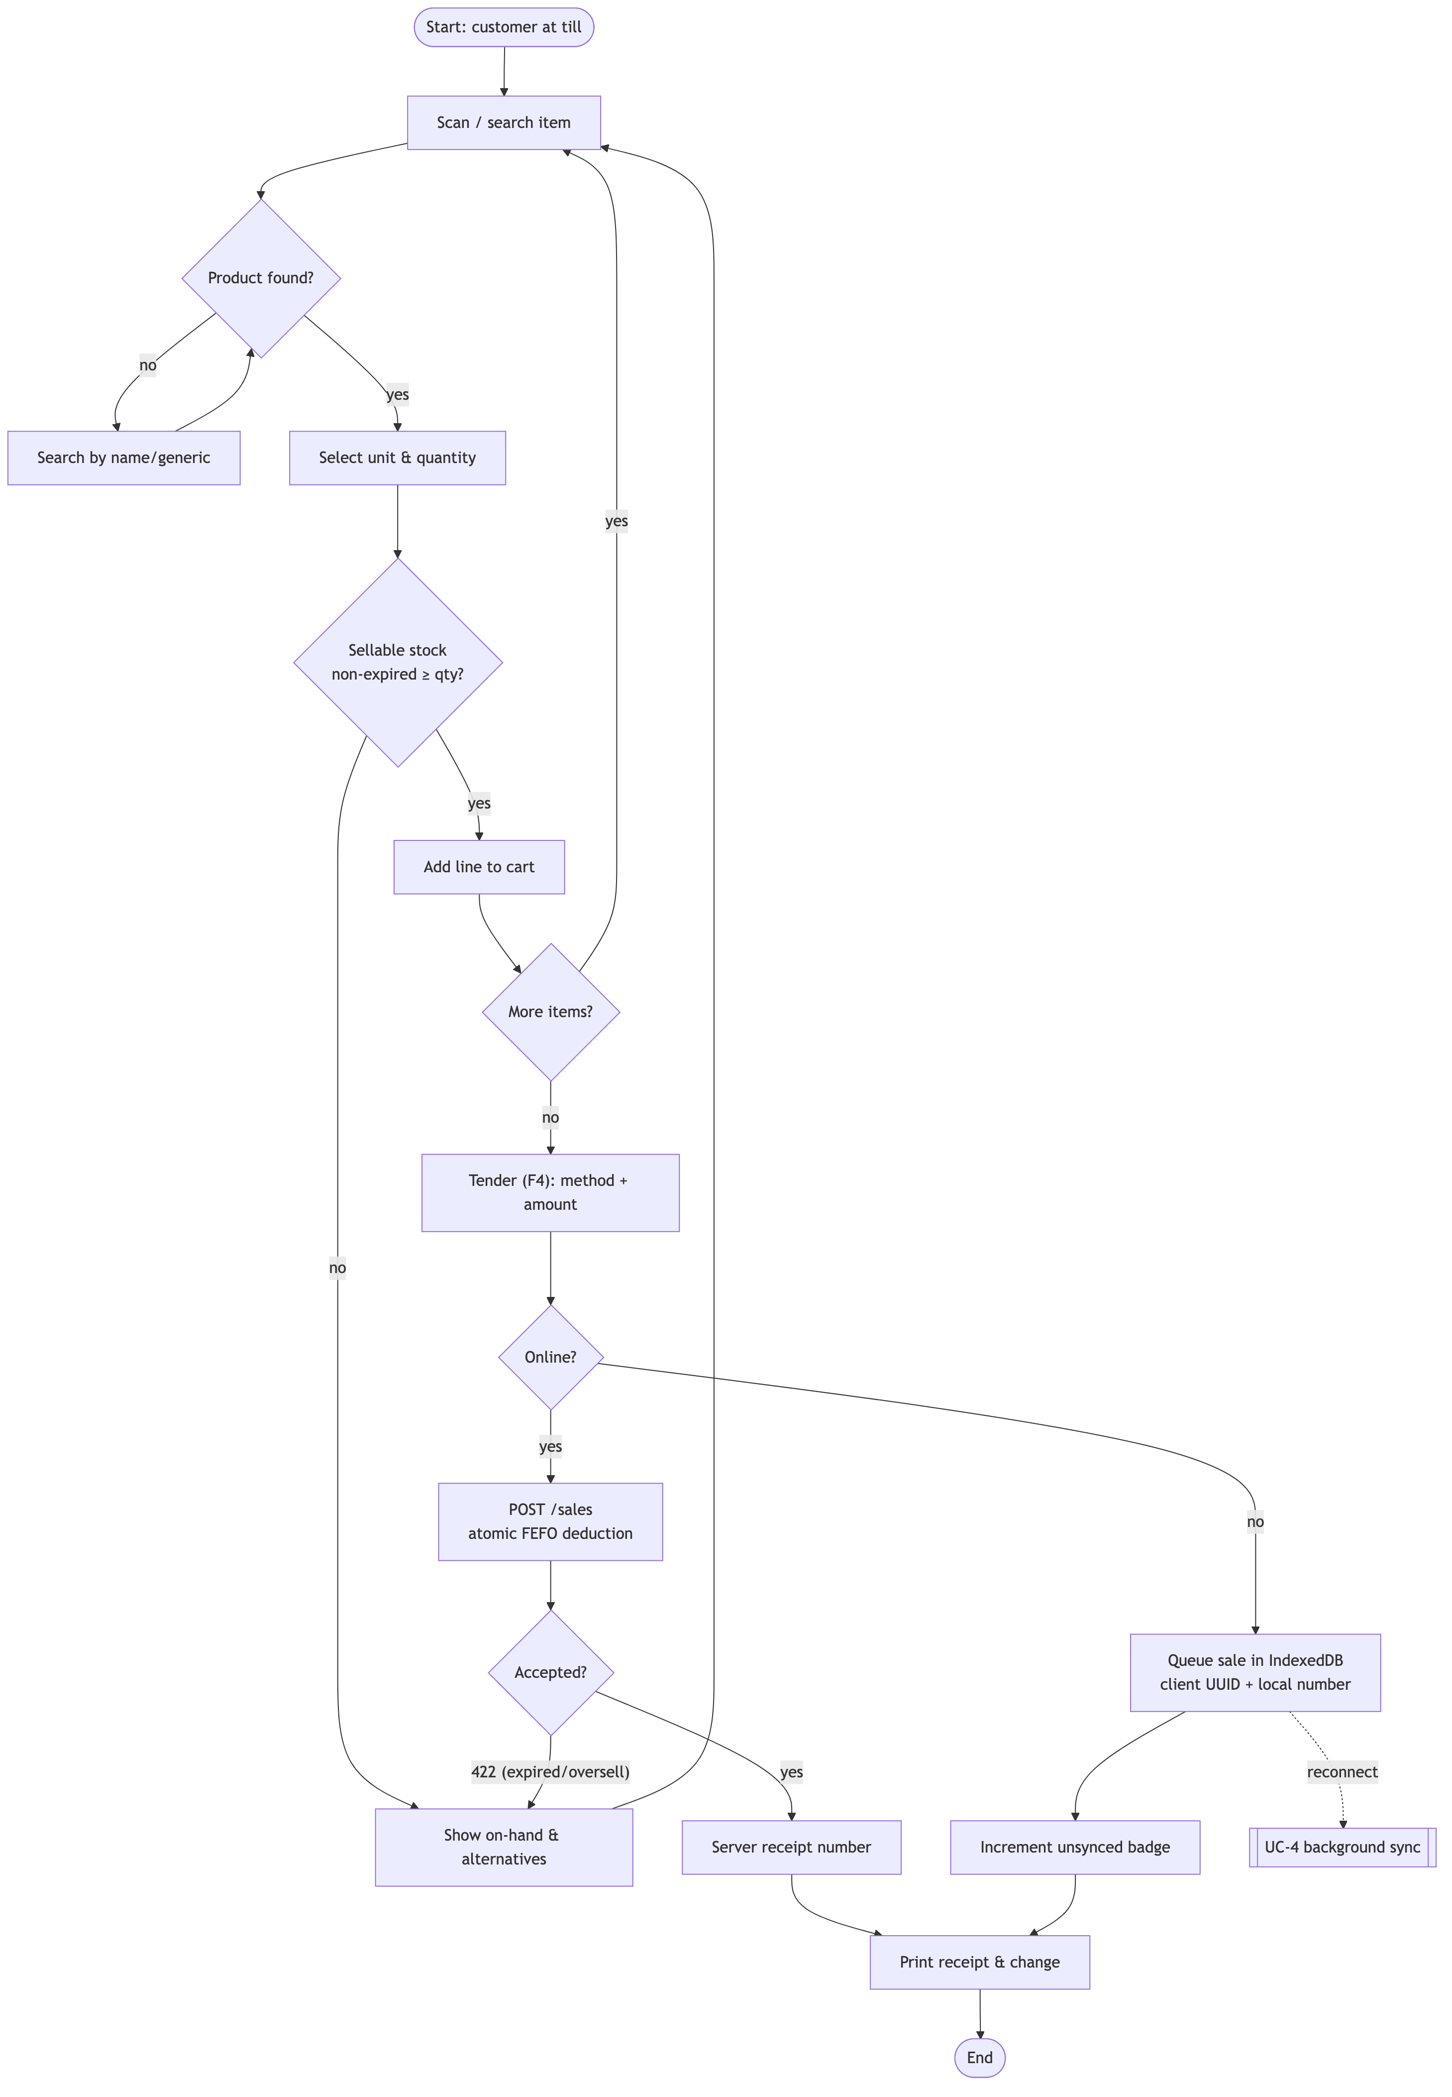
Figure 3

4. Activity diagram — Receive purchase order
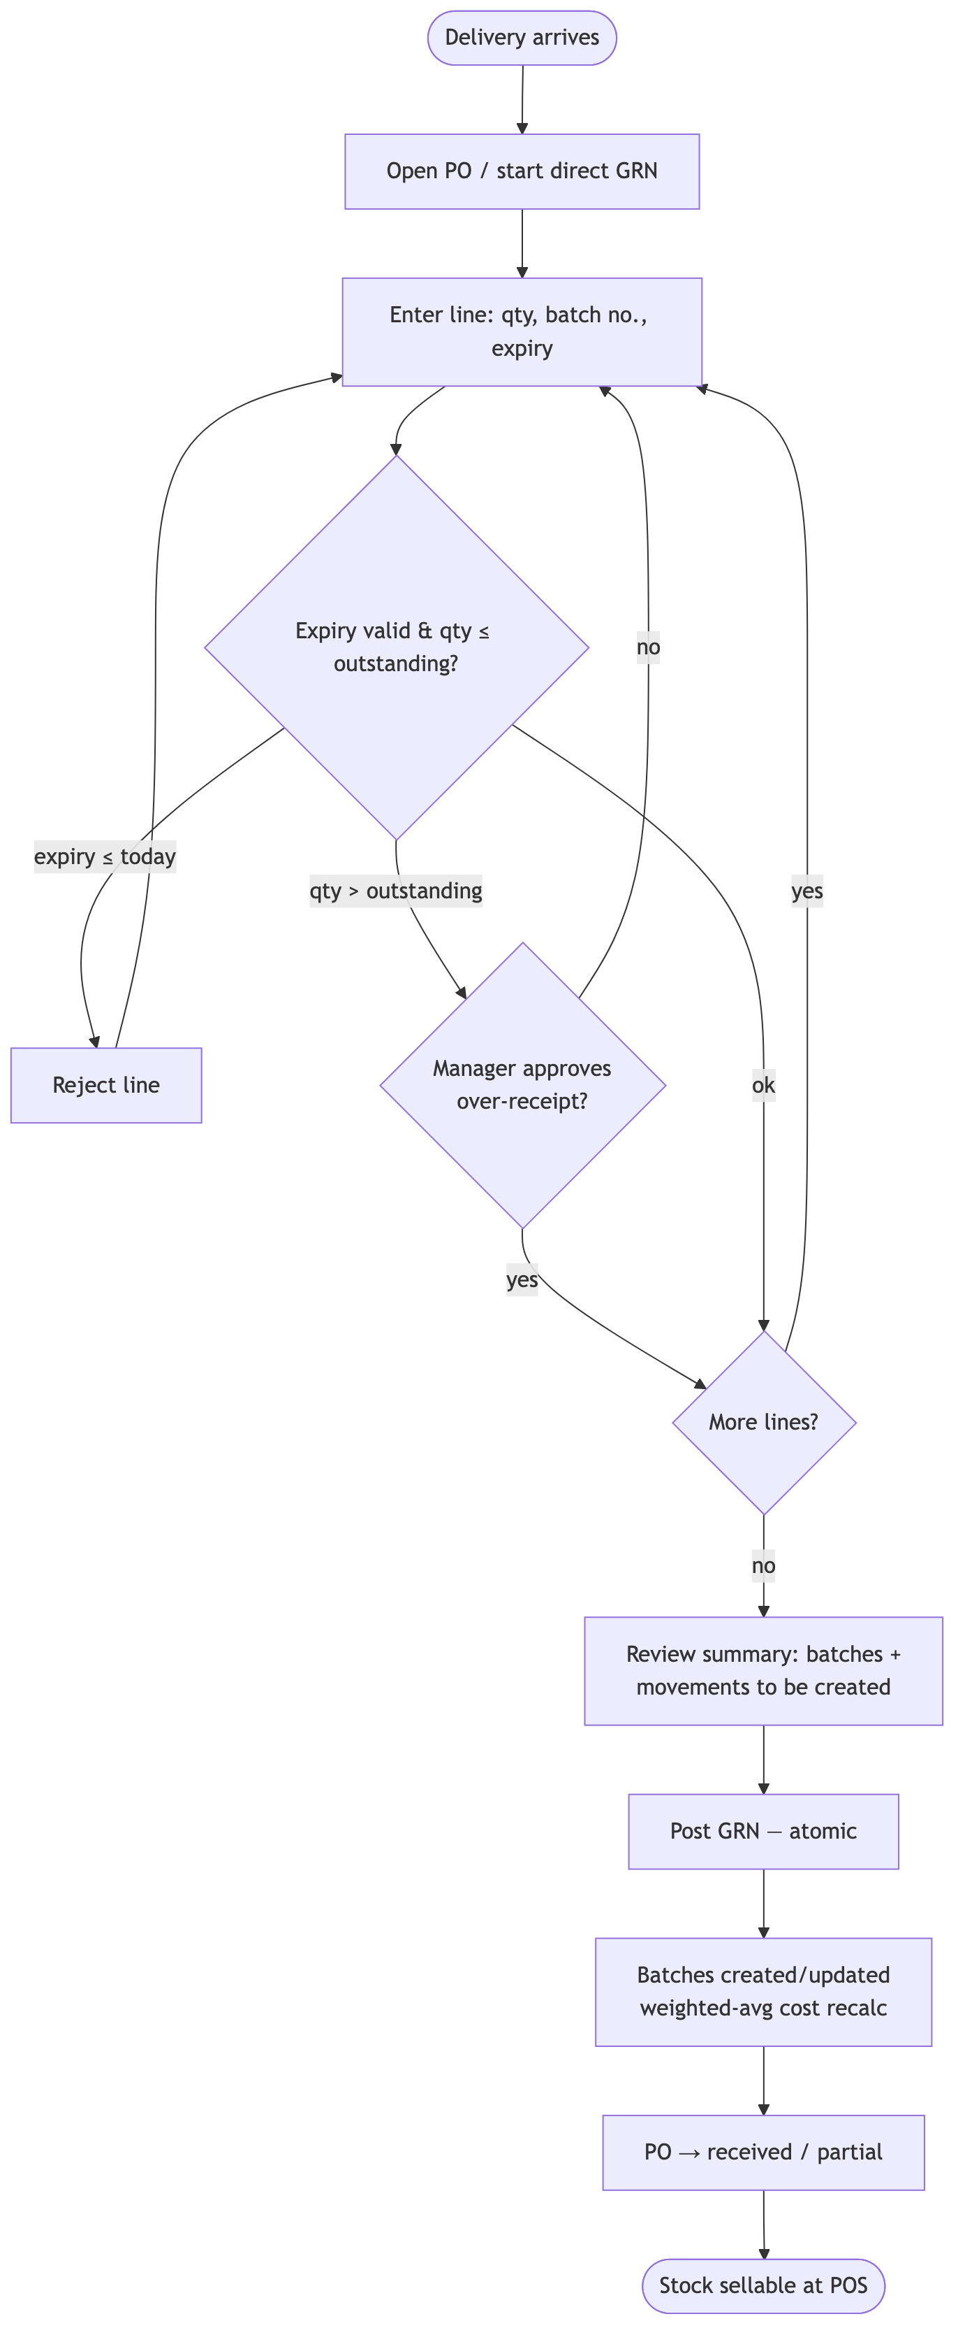
Figure 4

5. Context diagram (Level 0 system boundary)
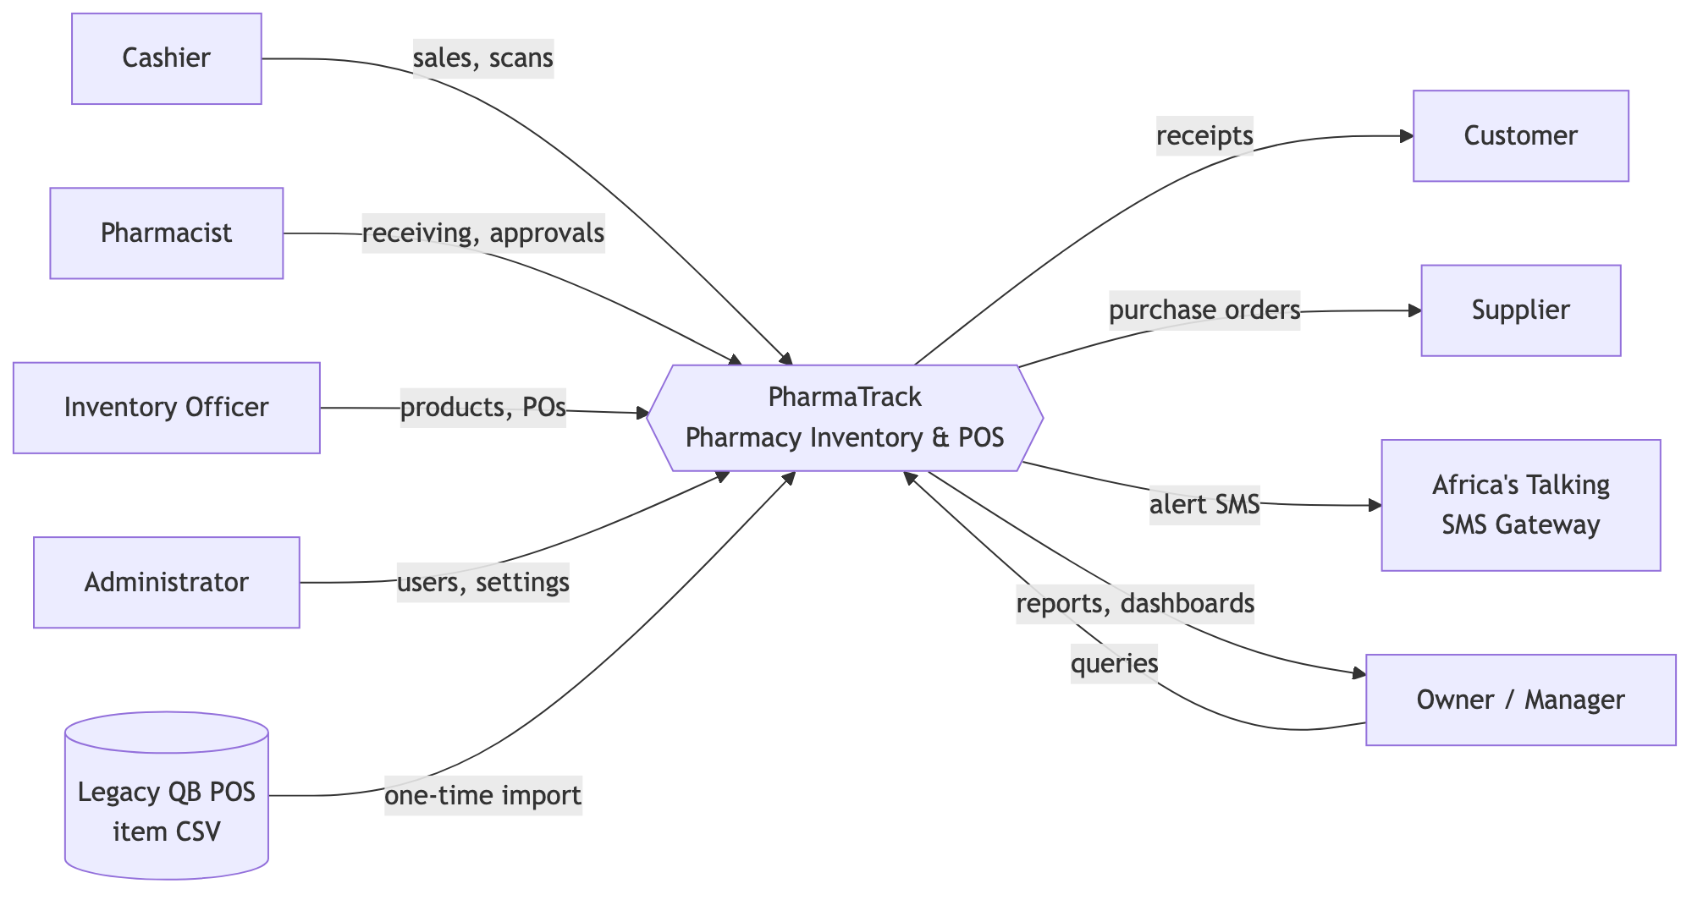
Figure 5

6. Data flow diagram — Level 0
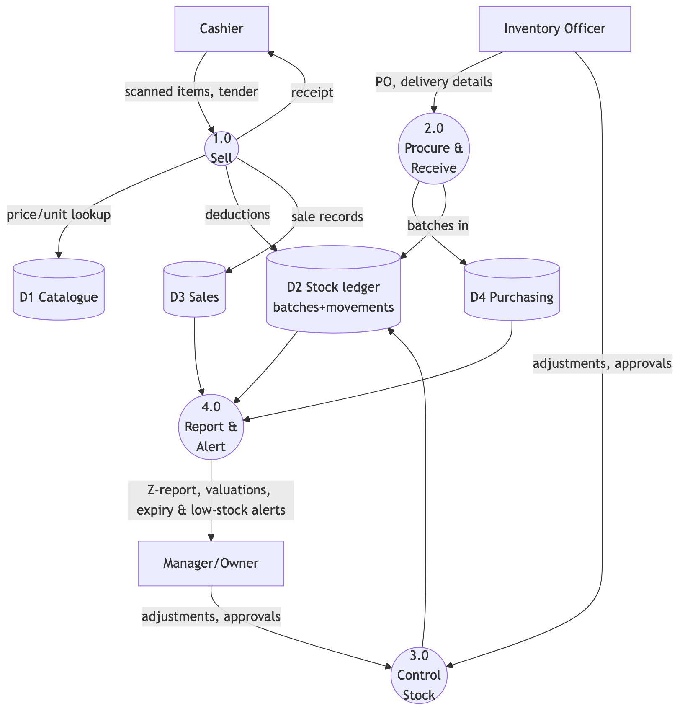
Figure 6

7. Data flow diagram — Level 1 of process 1.0 (Sell)
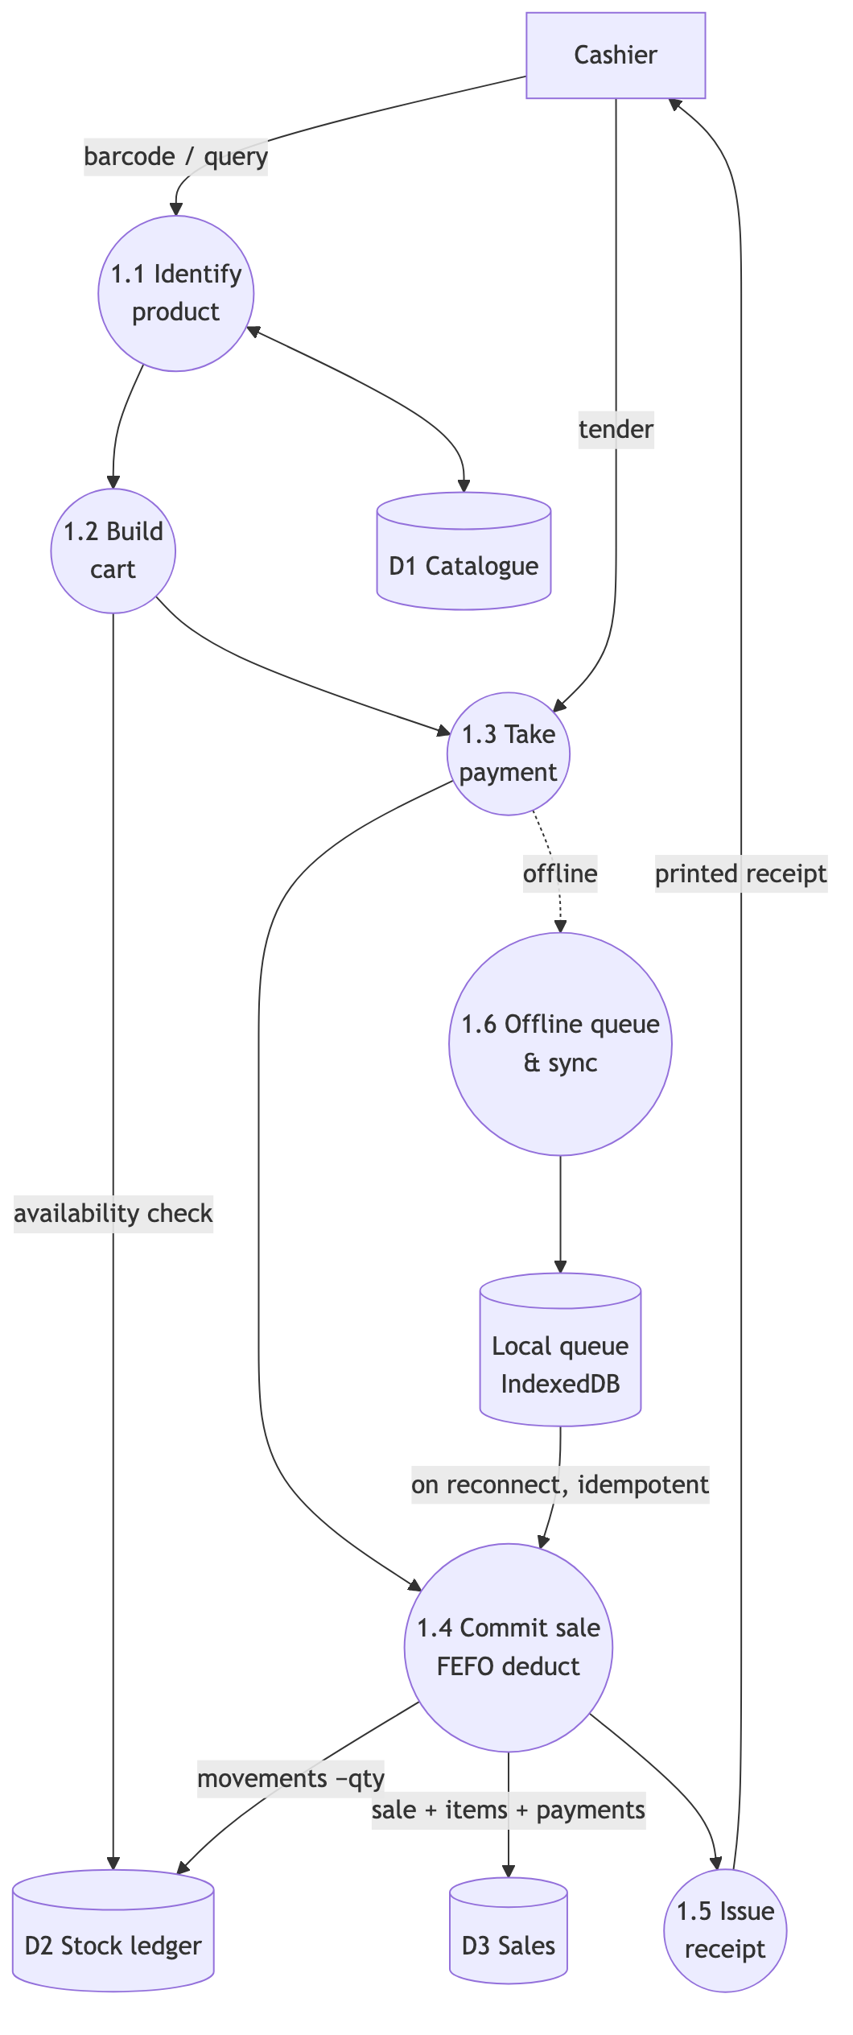
Figure 7

8. System architecture diagram
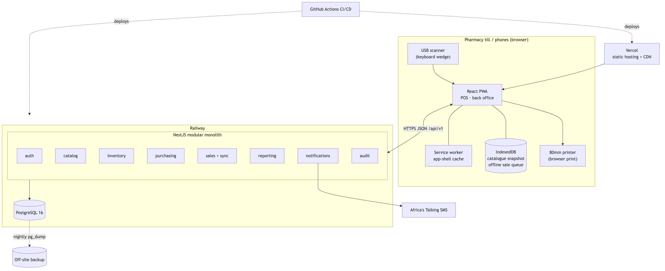
Figure 8
Module diagram: see the dependency table in ADR-001; arrows inside api are enforced by lint rules — sales → catalog/inventory/customers, purchasing → suppliers/catalog/ inventory, audit subscribes to events from all, reporting reads views only.

9. Class diagram (domain layer, key types)
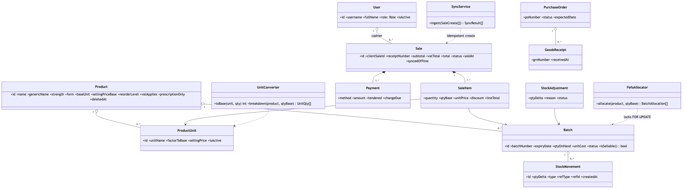
Figure 9

10. Sequence diagram — Online POS sale
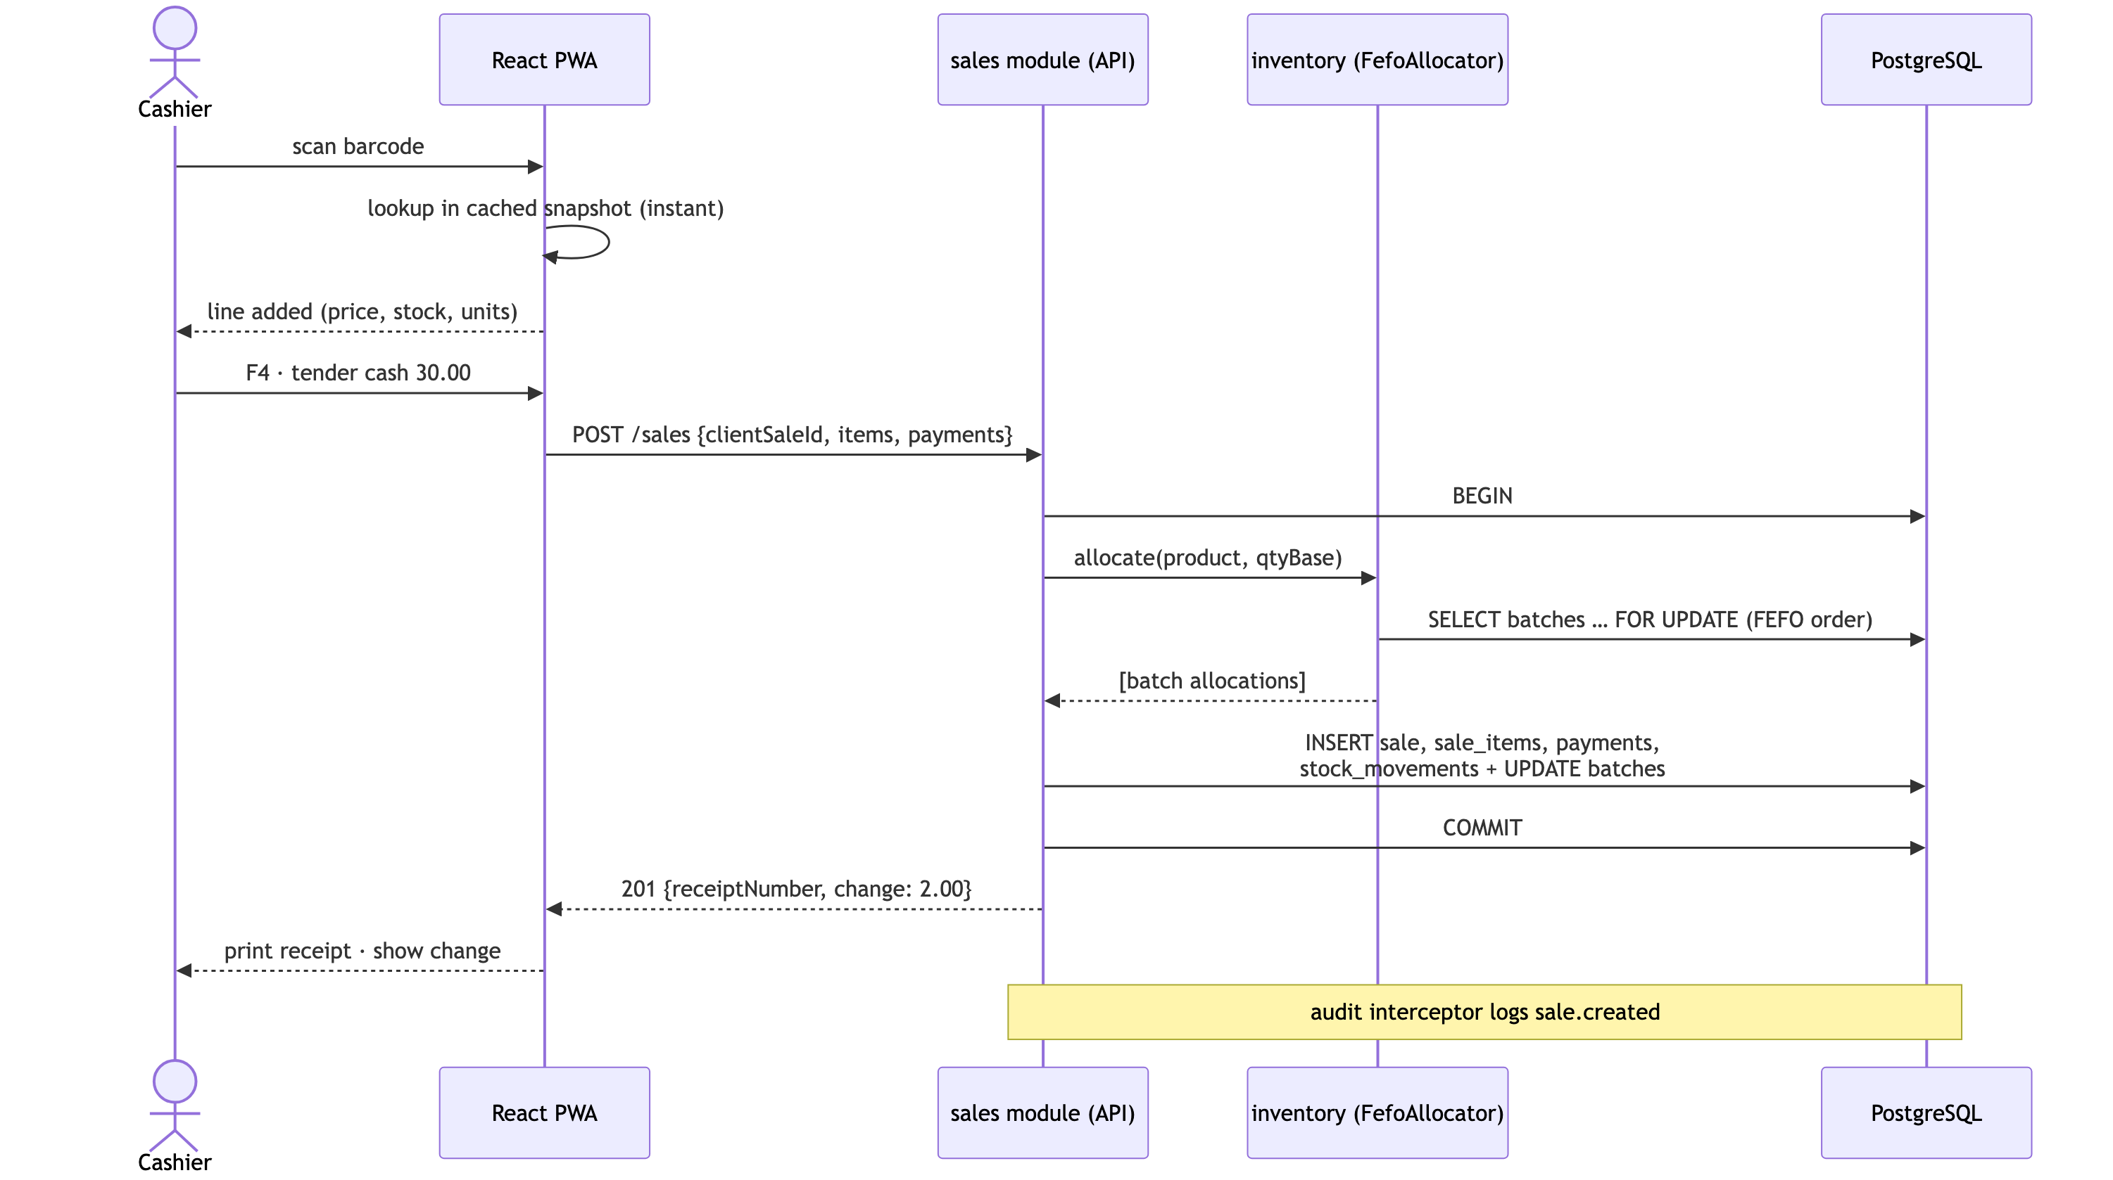
Figure 10

11. Sequence diagram — Offline sale & sync (ADR-006)
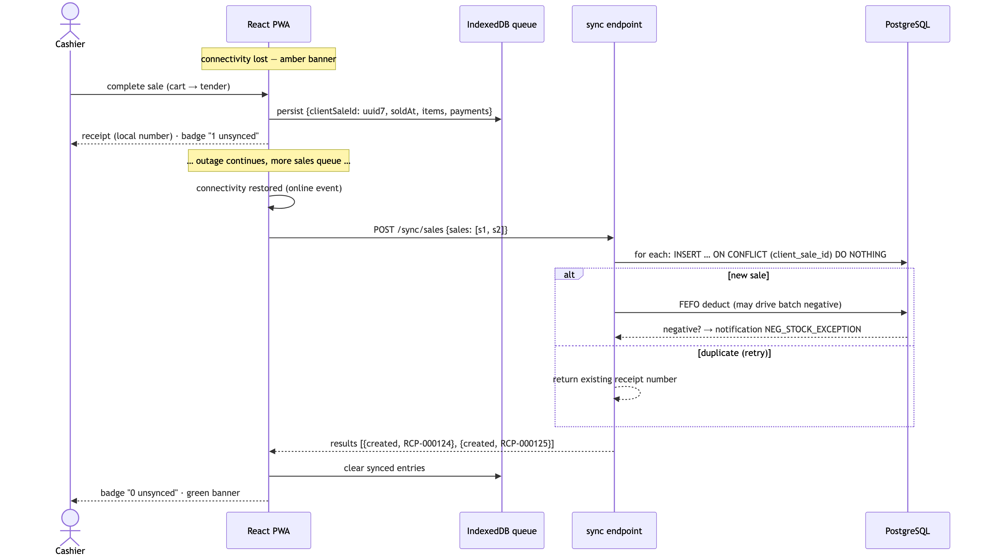
Figure 11

12. Sequence diagram — Login & token refresh (ADR-005)
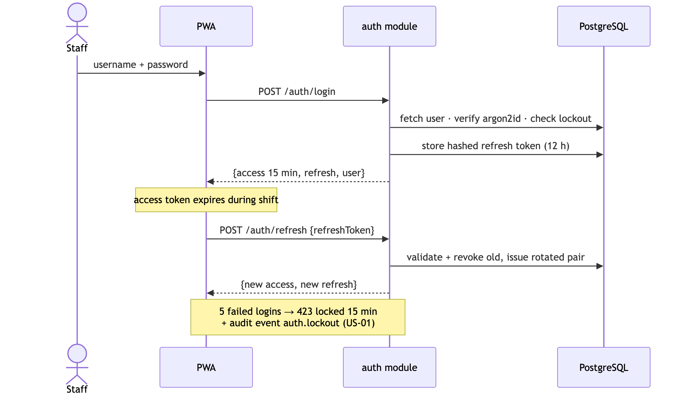
Figure 12

